Experiment 1.a.
Intput:
#include<iostream>
using namespace std;

int main(){

cout<<"hello world"<<endl;

}

Output:

Experiment 1.b.
Intput:
#include<iostream>
using namespace std;

int main(){
int n;

cout<<"enter the number you want to check : ";
cin>>n;

if(n%2==0){
cout<<n<<" is even number"<<endl;
}
else{
cout<<n<<" is odd number"<<endl;
}
}

Output:

Experiment 1.c.
Intput:
#include<bits\stdc++.h>
using namespace std;

int main(){

cout<<"***** WELCOME .. HOPE THIS CALCULATOR WILL HELP *****"<<endl;

int a,b,ch;

cout << "Enter two numbers: ";
cin>>a>>b;

cout<<"1:Add\n2:Sub\n3:Mul\n4:Div\n5:power "<<endl;
cout << "Enter your choice: ";
cin>>ch;

switch (ch){
case 1:{
int add=a+b;
cout<<"the sum is "<<add;
break;}

case 2:{
int sub=a-b;
cout<<"the sub is " <<sub;
break;}

case 3:{
int mul=a*b;
cout<<"the mul is "<<mul;
break;}

case 4:{
int div=a/b;
cout<<"the div is "<<div;
break;}

case 5:{
int power=pow(a,b);
cout<<"the power is "<<power;
break;

}

default:
cout<<"entered wrong input";

}

cout<<"\n"<<"***** HOPE YOU WILL COME NEXT TIME *****"<<endl;
return 0;
}

Output:
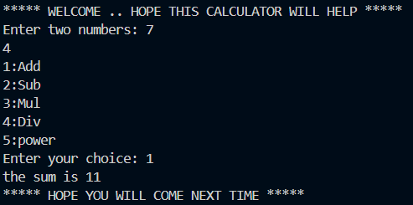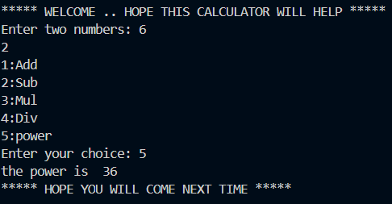

Experiment 2.a.
Intput:

#include<iostream>
using namespace std ;

void add(int a , int b , int c){
int sum=a+b+c;
cout<<"the addition of integer is :- "<<sum;
}

void add(float d, float e){
float sum=d+e;
cout<<"the addition of float is :- "<<sum;
}

int main(){
int a,b,c;
float d,e;

cout<<"enter 3 inputs for integer addition : "<<endl;
cin>>a>>b>>c;

cout<<"enter 2 input for float addition : "<<endl;
cin>>d>>e;

add(a,b,c);

cout<<"\n";

add(d,e);

return 0;
}

Output:
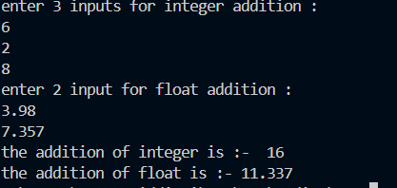

Experiment 2.b.
Intput:

#include<bits/stdc++.h>
using namespace std;
#define pi 3.14

int area(int s){
int sqaure = s*s;
return sqaure;
}

int area(int l , int b){
int rec = l*b;
return rec;
}

float area(float r){
float circle = pi * r * r;
return circle;

}

int main(){
int s,l,b;
float r;

cout<<"enter the side of sqaure : "<<endl;
cin>>s;

cout<<"enter the length and breadth of rectangle : "<<endl;
cin>>l>>b;

cout<<"enter the radius of circle : "<<endl;
cin>>r;

cout<<endl;

cout<<"the area of sqaure is : "<<area(s)<<endl;
cout<<"the area of rectangle is : "<<area(l,b)<<endl;
cout<<"the area of circle is : "<<area(r)<<endl;

}

Output:

